INS3121
SOIL MECHANICS
MIDTERM II
07.12.2015

Name and Surname:
Q.1 | Q.2 | Q.3 | Q.4 | TOTAL
Number:
Group:

- a) Explain briefly the concept of consolidation.

- What is consolidation coefficient? Explain briefly how it can be determined.

- What is preconsolidation pressure? Explain how it is used in settlement calculation.

- Explain briefly the concept of effective stress.

Name and Surname: Number: Group:
- A soil profile is shown below,
- Calculate the total stresses, pore water pressures and effective stresses at points A, B, and C.
- Calculate the effective stress difference at point C when GWT is lowered by 2 m.
- A foundation with a base pressure of 50 kPa, will be constructed over the sandy soil. Compute the stress increase at point D under the center of the foundation and by using 2:1 Method and Boussinesq chart.
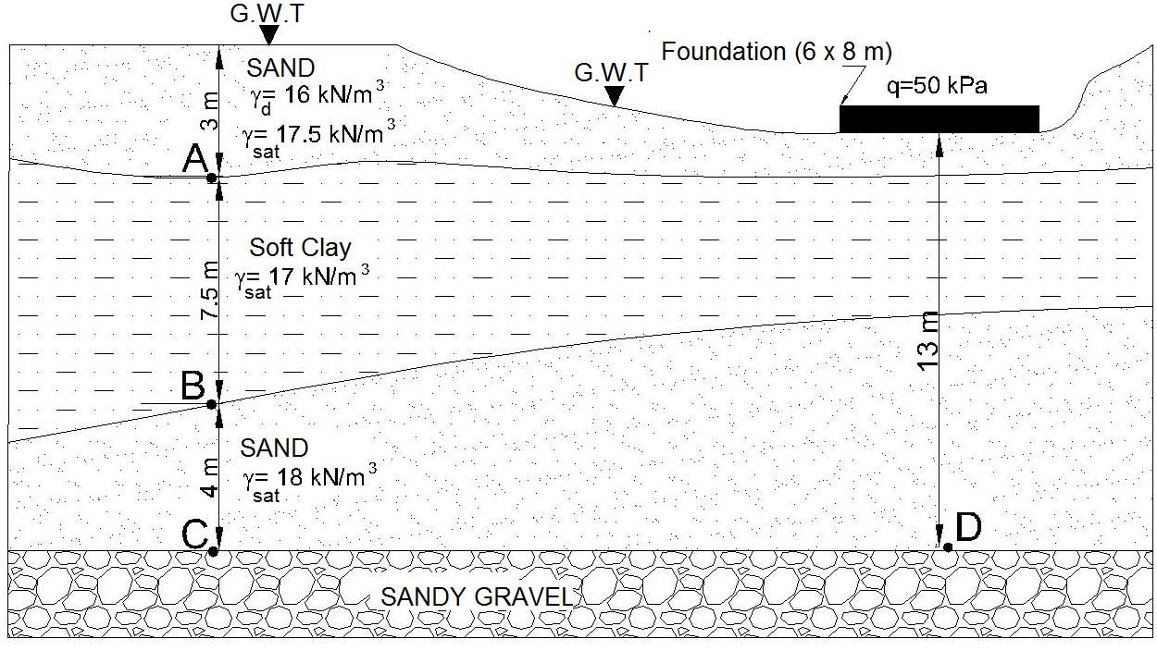

Name and Surname: Number: Group:
- A highway embankment of 2.5 m high is to be constructed over a 5.0 m thick clay layer. 20 mm thick clay sample was recovered from clay soil and a consolidation test performed in the laboratory to determine the compressibility parameters of the clay. Test results are given below in the table. The initial water content of clay is 32% and the specific weight (G_{s}) is 2.70. According to these results,
- Draw the (e) – (logσ’_{v}) curve and determine the preconsolidation pressure (σ_{p}’), compression index (C_{c}), and swelling index (C_{s}).
- What is the total settlement of the embankment? (Embankment covers a large surface in the field).
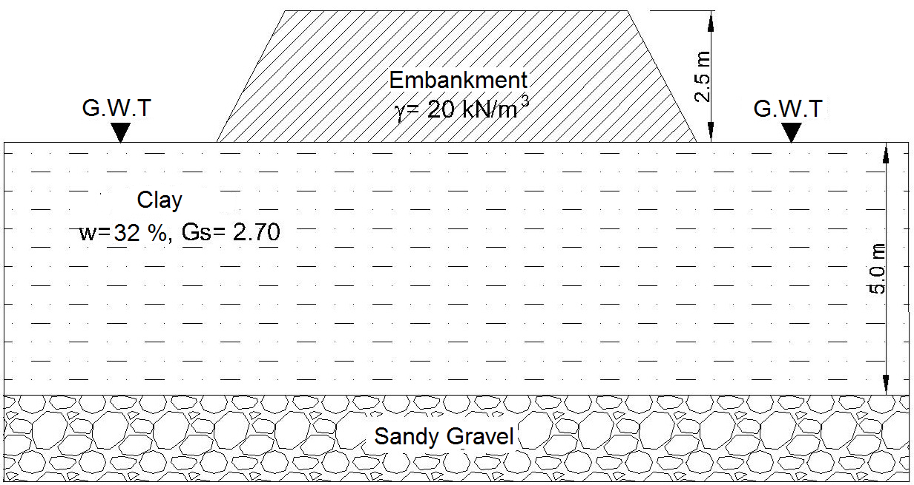
Stress (kPa) | Void ratio (e)
50 | 0.812
100 | 0.809
200 | 0.800
400 | 0.763
800 | 0.667
1600 | 0.563
3200 | 0.455
6400 | 0.358
1600 | 0.397
400 | 0.423
50 | 0.458
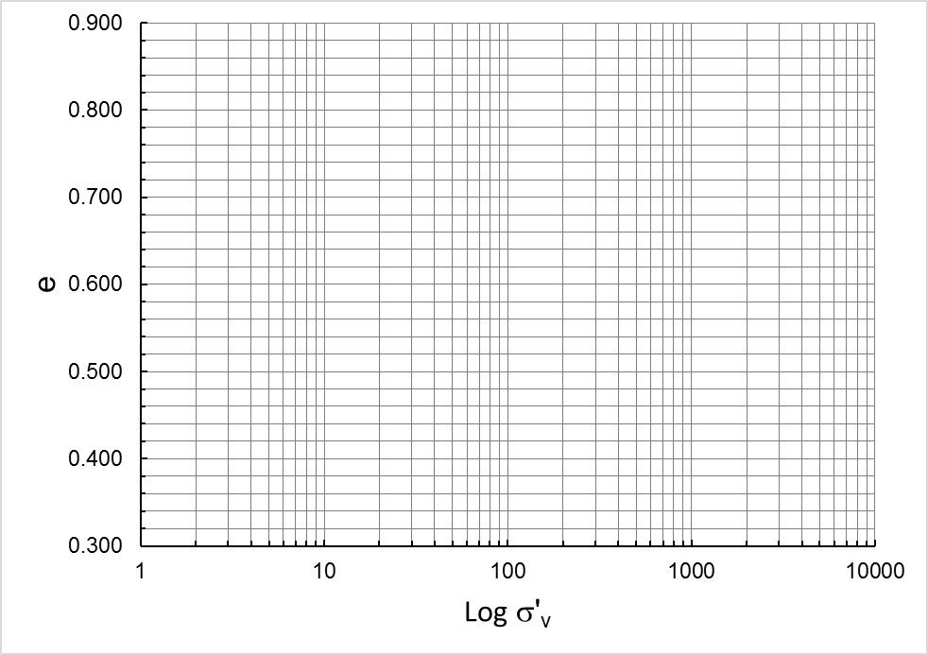

Name and Surname: Number: Group:
- Two foundations of a building are seated in a sandy soil as shown in the figure. According to this,
- Determine the total settlement under each foundation, and calculate the differential settlement. (Calculate the vertical effective stress increase by using 2:1 Method)
- If the settlement of the foundation A is 3.6 cm after 3 years, compute the time required for 90% consolidation for this foundation.
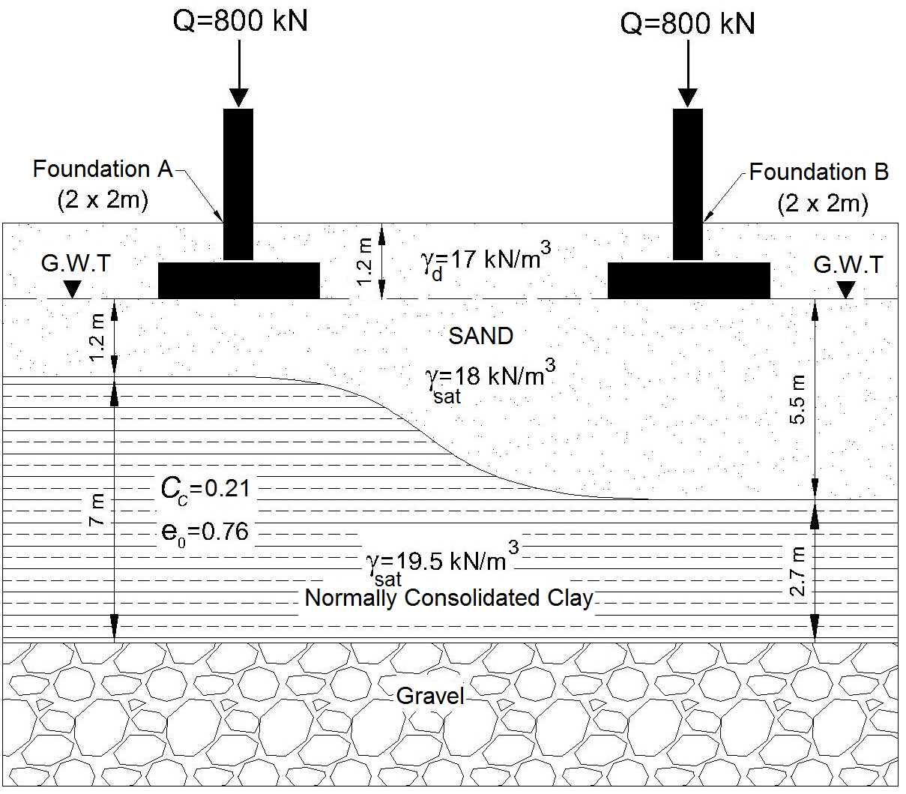
U (%) | T_{v}
10 | 0.008
20 | 0.031
30 | 0.071
40 | 0.126
50 | 0.197
60 | 0.287
70 | 0.408
80 | 0.567
90 | 0.848

Time is 90 minutes. Good Luck…

